Staff Resumes

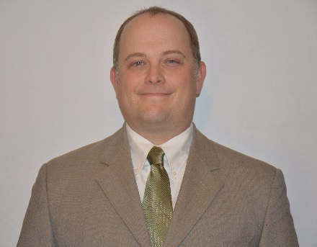
Greg Grabner, Senior GIS Analyst/Member
Greg brings 18 years of advanced experience in the GIS field. He is the managing Member at Frontier Geospatial, LLC and a Senior GIS Analyst. Aside from managing the company and projects he uses a variety of proprietary GIS Software, such as Open Source GIS (QGIS) and ESRI (ArcGIS Desktop and ArcGIS Pro). These programs have been used to create:

- Utility Networks, Green Infrastructure, Capacity, Management, Principal in Charge
Operations, Maintenance (CMOM) Map Edits, Storm Water and 18 Years of Experience
Sanitary Sewer Edits
- 401/404 state and federal permits
- Rosgen-based stream restoration to produce 3-D streams, wetland designs
- Extensive work in ArcGIS Server and ArcSDE using MS SQL, SQLlite and MS Access
- Demographic datasets

Greg is a member of the of the Indiana Geographic Information Council (IGIC), Kentucky Association of Mapping Professionals (KAMP) and Alliance Rural Water of Indiana. He has sat on several IGIC boards and helped with establishing SW Indiana GIS User Group.

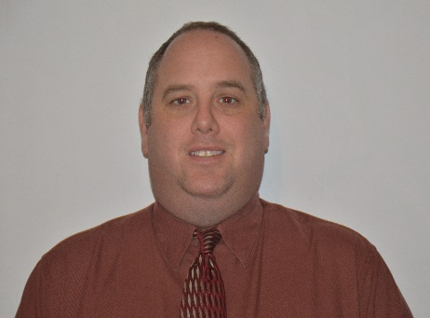
Philip Bernard, GIS Project Manager
Philip Bernard has more than 18 years of GIS and database experience, including two (2006-2008) as the Monroe County GIS Director. GIS has enabled Philip to work not only with maps, but with databases and programming languages to find solutions to a wide range of challenges. At Frontier Geospatial Philip has worked on the following projects:

- Francisco Water & Sewer Utility: Mapped networks using
QGIS & PostGIS Project Manager
- Evansville Water and Sewer Utility: Mapped water & sewer 18 Years of Experience
additions using ESRI Arc Desktop
- Lower Patoka River Conservancy District: Located parcels in conservancy boundary not being taxed at conservancy rate using GIS & database tools
- Kentucky River Properties: Mapped 15,000+ drill log locations using ArcGIS; developed ArcPyscript to assist mapping process

Philip is a member of the Indiana Geographic Information Council (IGIC) and the Kentucky Association of Mapping Professionals (KAMP) and has given presentations to both groups at workshops and state

